Graph Algorithm
Module 5 — Algorithm and Complexity
Presented by: Group 5

Previous Topic Review

Divide and Conquer
A problem-solving technique that breaks one large problem into smaller problems, solves each one, then combines the solutions.

Greedy Algorithms
An algorithmic paradigm that solves an optimization problem by making the locally optimal choice at each step, with the hope of finding a global optimum.

Dynamic Programming
Solves a big problem by breaking it into smaller sub-problems and saving their answers in memory so you don't repeat work.

Backtracking
An algorithm design technique used to solve problems by trying different possible solutions one at a time. If a solution does not work, the algorithm goes back (backtracks) to the previous step and tries another option.

Branch and Bound Algorithm
A method used in combinatorial optimization problems to systematically search for the best solution. It is commonly used in problems like the traveling salesman, job scheduling, and the 0/1 knapsack problem.

Module 5 — Topic Overview
- Breadth-First Search (BFS)
- Depth-First Search (DFS)
- Topological Sorting
- Dijkstra's Algorithm
- Bellman-Ford Algorithm
- Floyd-Warshall Algorithm
- Prim's Algorithm
- Kruskal's Algorithm

1. Breadth-First Search (BFS)
Breadth First Search (BFS) is a graph traversal algorithm that starts from a source node and explores the graph level by level. First, it visits all nodes directly adjacent to the source. Then, it moves on to visit the adjacent nodes of those nodes, and this process continues until all reachable nodes are visited.
Time complexity: O(V + E)

How BFS Works
- Choose a starting node.
- Mark it as visited.
- Add it to the queue.
- Remove the first node from the queue.
- Visit all of its unvisited neighboring nodes and add them to the queue.
- Repeat until the queue is empty.

Example
Sample graph (undirected), connected as follows:
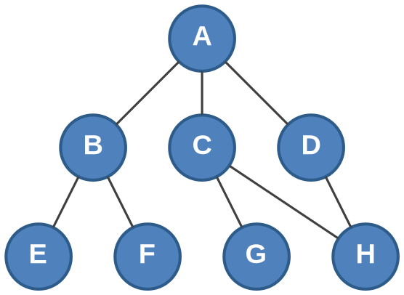
Edge | Edge | Edge
A – B | A – C | A – D
B – E | B – F | C – G
C – H | D – H

Starting a BFS at node A (visiting neighbors in alphabetical order):
Queue: [A] → visit A, enqueue B, C, D
Queue: [B, C, D] → visit B, enqueue E, F
Queue: [C, D, E, F] → visit C, enqueue G, H
Queue: [D, E, F, G, H] → visit D (no new neighbors)
Queue: [E, F, G, H] → visit E (no new neighbors)
Queue: [F, G, H] → visit F (no new neighbors)
Queue: [G, H] → visit G (no new neighbors)
Queue: [H] → visit H (no new neighbors)
Traversal order: A, B, C, D, E, F, G, H

2. Depth-First Search (DFS)
DFS is a graph/tree traversal algorithm that explores as far as possible along each branch before backtracking.

How DFS Works
- Start at a chosen node (the root, or any starting point).
- Visit that node, mark it as visited.
- Recursively visit an unvisited neighbor.
- Keep going deeper until you hit a node with no unvisited neighbors.
- Backtrack to the previous node and try its next unvisited neighbor.
- Repeat until every reachable node has been visited.

Example
Sample graph (undirected), connected as follows:
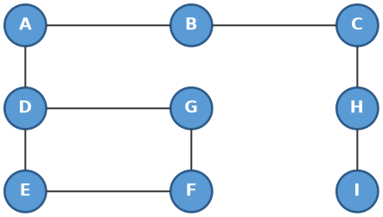
Edge | Edge | Edge
A – B | D – G | H – I
B – C | D – E | E – F
A – D | C – H | G – F

Starting a DFS at node A (visiting neighbors in alphabetical order):
Visit A → visit B → visit C → visit H → visit I (dead end, backtrack)
Backtrack to A → visit D → visit E → visit F → visit G (dead end, backtrack — all visited)
Traversal order: A, B, C, H, I, D, E, F, G

3. Topological Sorting
The process of arranging the vertices (nodes) of a directed graph in a specific order based on their dependencies.
It follows the rule that if there is an edge A → B, A must come before B in the ordering.
It is only possible in a Directed Acyclic Graph (DAG), which is a graph with no cycles.

How Topological Sorting Works
- Identify the vertices that have no incoming edges.
- Choose one of these vertices and add it to the ordering.
- Remove the chosen vertex and its outgoing edges.
- Repeat the process until all vertices are arranged.
- The resulting sequence is the topological order.

Example
Sample directed acyclic graph (DAG):
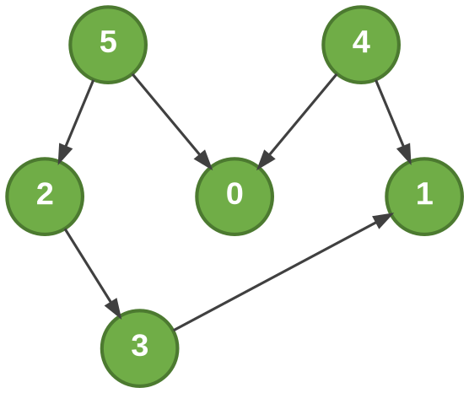
Edge | Edge | Edge
5 → 2 | 5 → 0 | 4 → 0
4 → 1 | 2 → 3 | 3 → 1

Applying the algorithm (repeatedly picking a vertex with no remaining incoming edges):
Step | Vertex Chosen | Why It Qualifies | Ordering So Far
1 | 4 | No incoming edges to start with | 4
2 | 5 | No incoming edges to start with | 4, 5
3 | 2 | Its only incoming edge (5→2) is gone | 4, 5, 2
4 | 0 | Both incoming edges (5→0, 4→0) are gone | 4, 5, 2, 0
5 | 3 | Its incoming edge (2→3) is gone | 4, 5, 2, 0, 3
6 | 1 | Both incoming edges (4→1, 3→1) are gone | 4, 5, 2, 0, 3, 1

Topological order: 4, 5, 2, 0, 3, 1
Note: a topological order is not always unique. Since 4 and 5 have no dependency between them, swapping their positions (e.g. 5, 4, 2, 0, 3, 1) is also a valid ordering.

4. Dijkstra's Algorithm
Developed by Edsger Wybe Dijkstra.
Dijkstra's algorithm finds the shortest path from a starting node to every other node in a weighted graph (where edges have costs/distances, not just connections).
Note: This is different from DFS/BFS, which just explore connectivity — Dijkstra's tracks cost, not just reachability.

The Core Idea: Greedy + Priority Queue
Always expand outward from whichever unvisited node currently has the smallest known distance. This greedy choice guarantees correctness as long as edge weights are non-negative.

Relaxation Formula
if dist[u] + weight(u, v) < dist[v]:
dist[v] = dist[u] + weight(u, v)
In words: new candidate distance to v = dist[u] + weight(u, v). If it beats the current best-known distance to v, update it.

Algorithm Steps
- Set distance to the start node = 0, all others = infinity.
- Put all nodes in a priority queue, ranked by current known distance.
- Pop the node with the smallest distance. Mark it finalized.
- For each neighbor, relax the edge.
- Repeat until the queue is empty.

Example: A to C
Graph edges and weights:
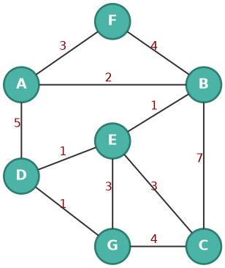
Edge | Weight | Edge | Weight
A – F | 3 | B – E | 1
A – B | 2 | B – C | 7
A – D | 5 | D – E | 1
F – B | 4 | D – G | 1
E – G | 3 | G – C | 4
E – C | 3

Running Dijkstra from source A:
Node | Cost | Previous
A | 0 | —
B | 2 | A
C | 6 | E
D | 4 | E
E | 3 | B
F | 3 | A
G | 5 | D

Shortest path from A to C: A → B → E → C (total cost = 6)

Conclusion
Dijkstra's algorithm finds the shortest path from a start node to every other node in a weighted graph by greedily expanding the closest unvisited node first — using a priority queue for efficiency — which is only correct when all edge weights are non-negative.

5. Bellman-Ford Algorithm
Developed by Richard Bellman and Lester Ford Jr.
The Bellman-Ford Algorithm is a graph algorithm used to find the shortest path from a starting vertex to other vertices in a weighted graph.
- Finds the shortest path
- Starts from a source vertex
- Works with weighted graphs
- Can handle negative edge weights
- Can detect negative weight cycles

Key Terms
- Vertex – a point or node in the graph
- Edge – connection between two vertices
- Weight – value assigned to an edge
Example: A ----4----> B (A and B are vertices, the arrow is an edge, 4 is the weight.)

Relaxation
Checking if a shorter path exists and updating the distance if necessary.
if distance[u] + weight < distance[v]:
distance[v] = distance[u] + weight
u = starting/source vertex of the edge; v = destination vertex of the edge; weight = the cost of going from u to v.

How Bellman-Ford Works
- Initialize distances.
- Set source = 0.
- Set other vertices = infinity (∞).
- Relax all edges V − 1 times.
- Check for a negative weight cycle.

Example Graph
Edges and weights (note the negative edge B → C):
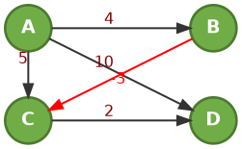
Edge | From → To | Weight
1 | A → B | 4
2 | A → C | 5
3 | B → C | −3
4 | C → D | 2
5 | A → D | 10

Finding the Initial Distances
Source vertex = A. Set A's distance to 0, and all others to infinity (∞).
Vertex | Initial Distance
A | 0
B | ∞
C | ∞
D | ∞

After relaxing every edge V − 1 = 3 times, the shortest distances from source A are:
Vertex | Shortest Distance | Path from A
A | 0 | A (cost = 0)
B | 4 | A → B (cost = 4)
C | 1 | A → B → C (cost = 1)
D | 3 | A → B → C → D (cost = 3)

Negative Weight Cycle
Example: A → B = 2, B → C = −4, C → A = 1
Total: 2 + (−4) + 1 = −1 → a negative total means a negative weight cycle exists.

Pseudocode
BellmanFord(Graph, Source)
Set source distance = 0
Set other distances = infinity
Repeat V - 1 times:
For every edge:
Relax the edge
Check every edge again
If distance can still decrease:
Negative cycle exists

Conclusion
Bellman-Ford finds the shortest paths from a single source, handles negative edge weights, and detects negative weight cycles.

6. Floyd-Warshall Algorithm
Developed by Robert W. Floyd, Stephen Warshall, and Bernard Roy.
The Floyd-Warshall Algorithm is a graph algorithm used to find the shortest paths between every pair of vertices in a weighted graph.
- Finds the shortest path between all pairs of vertices
- Works with weighted graphs
- Can handle negative edge weights
- Can detect negative weight cycles
- Uses a dynamic programming approach
- Continuously checks if going through another vertex gives a shorter path

Key Idea
Repeatedly checks whether going through another vertex provides a shorter path between two vertices.

Formula
dist[i][j] = min( dist[i][j], dist[i][k] + dist[k][j] )
i = the starting vertex, j = the destination vertex, k = the intermediate vertex being checked as a possible shortcut.

Worked Example
Example graph: A → B = 4, B → C = 2, C → A = 11. (∞ = no direct path, 0 = distance to self)
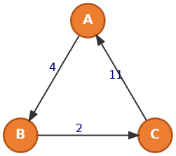
Initial distance matrix D⁰ (direct edge weights only):
From \ To | A | B | C
A | 0 | 4 | ∞
B | ∞ | 0 | 2
C | 11 | ∞ | 0

Final distance matrix, after checking every vertex as a possible intermediate stop:
From \ To | A | B | C
A | 0 | 4 | 6
B | 13 | 0 | 2
C | 11 | 15 | 0

7. Prim's Algorithm
Associated with Vojtěch Jarník, Robert C. Prim, and Edsger W. Dijkstra.

What Is a Minimum Spanning Tree (MST)?
A Minimum Spanning Tree is a tree that:
- Connects all vertices
- Has no cycles
- Uses exactly V − 1 edges
- Has the minimum possible total weight

Finding the Minimum Spanning Tree
Prim's algorithm is a greedy algorithm used to connect all vertices with the minimum possible total edge weight.
Key idea: Start from one vertex and repeatedly add the cheapest edge that connects to an unvisited vertex.

Example
Graph edges and weights (7 vertices numbered 1–7):
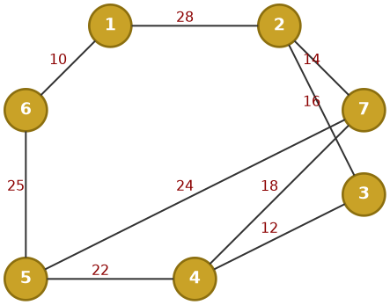
Edge | Weight | Edge | Weight
1–2 | 28 | 3–4 | 12
1–6 | 10 | 4–5 | 22
2–3 | 16 | 4–7 | 18
2–7 | 14 | 5–6 | 25
5–7 | 24

Running Prim's algorithm starting at vertex 1:
Step | Edge Added | Weight | Tree so Far
1 | 1 – 6 | 10 | {1, 6}
2 | 6 – 5 | 25 | {1, 5, 6}
3 | 5 – 4 | 22 | {1, 4, 5, 6}
4 | 4 – 3 | 12 | {1, 3, 4, 5, 6}
5 | 3 – 2 | 16 | {1, 2, 3, 4, 5, 6}
6 | 2 – 7 | 14 | {1, 2, 3, 4, 5, 6, 7}

Total minimum weight = 10 + 25 + 22 + 12 + 16 + 14 = 99

How Prim's Algorithm Works
- Choose a starting vertex.
- Look at all edges connected to the current tree.
- Choose the lowest-weight edge that connects to an unvisited vertex.
- Add that edge and vertex to the tree.
- Repeat until all vertices are connected.
Key rule: Always choose the cheapest edge that expands the tree.

8. Kruskal's Algorithm
Developed by Joseph Kruskal.
Kruskal's Algorithm is a method used to find the Minimum Spanning Tree (MST) of a weighted graph.
In simple words: it connects all the nodes using the lowest possible total edge weight, without creating a cycle.
Key idea: Choose the smallest edge first, but do not create a cycle.

How Kruskal's Algorithm Works
- List all edges in the graph.
- Sort the edges from smallest to largest weight.
- Select the smallest edge.
- Check for a cycle.
- If it does not create a cycle, add it to the MST.
- Continue until all vertices are connected.

Example
Graph edges and weights (vertices A–G):
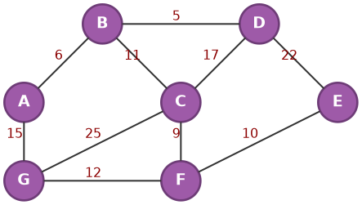
Edge | Weight | Edge | Weight
B – D | 5 | G – F | 12
A – B | 6 | A – G | 15
C – F | 9 | C – D | 17
F – E | 10 | D – E | 22
B – C | 11 | G – C | 25

Edges sorted from smallest to largest weight, and whether each is added to the MST:
Edge | Weight | Creates a Cycle? | Added to MST?
B – D | 5 | No | Yes
A – B | 6 | No | Yes
C – F | 9 | No | Yes
F – E | 10 | No | Yes
B – C | 11 | No | Yes
G – F | 12 | No | Yes
A – G | 15 | Yes | No
C – D | 17 | Yes | No
D – E | 22 | Yes | No
G – C | 25 | Yes | No

MST edges: B–D, A–B, C–F, F–E, B–C, G–F. Total weight = 5 + 6 + 9 + 10 + 11 + 12 = 53

Reference Links
- Depth First Search (2021). https://youtu.be/by93qH4ACxo?si=IYvYgQ7VG8BROEYd
- Dijkstra, E. W. (1959). A note on two problems in connexion with graphs. Numerische Mathematik, 1(1), 269–271. https://doi.org/10.1007/BF01386390
- Cormen, T. H., Leiserson, C. E., Rivest, R. L., & Stein, C. Introduction to Algorithms (CLRS), Sections 24.2–24.3.
- MIT OpenCourseWare, 6.006 Introduction to Algorithms — Lecture 13: Dijkstra.
- MIT OpenCourseWare — Lecture on Bellman-Ford (Spring 2020).
- MIT OpenCourseWare — Lecture 17: Bellman-Ford (Fall 2011).
- MIT OpenCourseWare — Lecture Notes (Spring 2008).
- Wikipedia — Bellman–Ford algorithm.
- GeeksforGeeks — Breadth First Search (BFS) for a Graph.
- GeeksforGeeks — Topological Sorting.

